**Lamb Kabobs**

My lamb kabobs are savory, tasty, and healthy. I use spices that help keep blood sugar low and increase metabolism, such as cinnamon and red chili powder. These are a comfort food and a great snack to have at parties and when family or friends come over along with hot sauce, ketchup or chutney. And they’re low sugar and low calorie – but others would never know since they taste so delicious!

[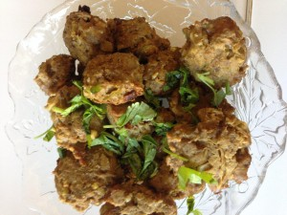](http://test5.nataliareal.com/wp-content/uploads/2013/12/lamb_cropped.jpg)

Prep Time: 20 minutes  
Total Time: 50 minutes  
Servings: 25 kabobs

**Ingredients**

* 2 pounds of ground lamb (vegetarian alternative: Boca crumbles)
* 4-6 serranos or jalapeno peppers, chopped (based on your preference for spiciness)
* ½ onion, chopped
* 8-10 garlic cloves, chopped
* 3 tablespoons ginger, chopped
* ¼ cup cilantro (whole pieces)
* 2 bay leaves, crumbled
* 2 teaspoons salt
* ½ teaspoon chili powder
* 1 teaspoon cinnamon powder
* 2 teaspoons of garam masala (or 1 teaspoon cumin powder and 1 teaspoon coriander powder)
* Juice of 1 lemon
* Garnish: ¼ cup cilantro, chopped, ¼ cup sliced long red onions, and/or sliced radishes

**Directions**

1. Preheat oven to 400 degrees

2. Knead lamb in bowl

3. Combine all other ingredients in a separate small bowl, and then mix into lamb

4. Roll mixture into large balls and place on cookie dough pan covered with foil. The balls will shrink when cooking so make them larger than you would like

[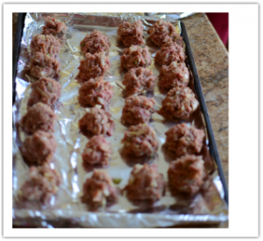](http://test5.nataliareal.com/wp-content/uploads/2013/12/1387761774.png)

5. Bake for 20 minutes. Turn kabobs over. Cook other side for 10-12 minutes. The kabobs will be brown all over, with no areas of pink, when they are done

6. Remove from the oven, cool for a couple minutes, squeeze with lemon juice and garnish

*Serve with mint chutney, Sriracha sauce (or any other hot sauce) or ketchup. Enjoy!*